Chapter 14, Problem 104.

A low-quality factor, double-tuned bandpass filter is shown in Fig. 14.112. Use PSpice to generate the magnitude plot of V_{o}(ω).

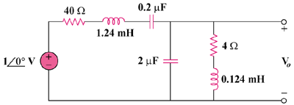

Figure 14.112
For Prob. 14.104.

